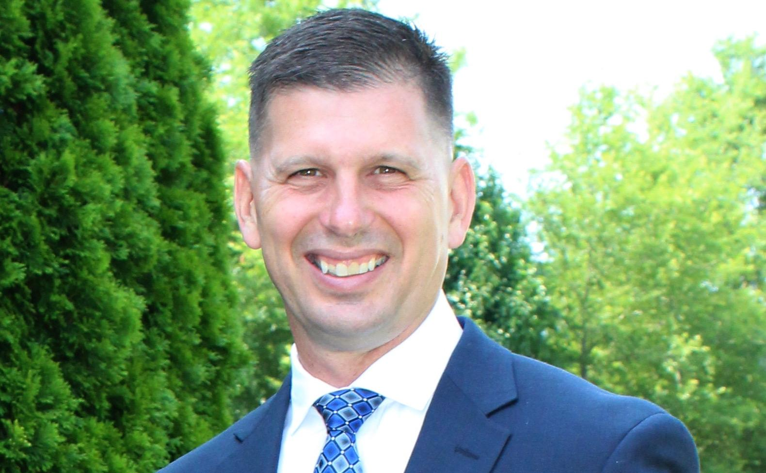

Mark F. Riedy
Mark F. “Speedy” Riedy is the Director of Project Management Office (PMO) and Vice President of Operations at Spectrum Communications Incorporated, where he serves as a senior executive leader responsible for enterprise-wide program execution, operational performance, and strategic alignment across the company’s Federal and Department of Defense portfolio.
In this role, Mr. Riedy established and leads Spectrum’s PMO, implementing standardized governance, lifecycle management, and performance frameworks aligned with ISO 9001:2015, CMMI Services Level 3, and SAFe Agile methodologies. He provides executive oversight for all programs and projects, ensuring consistent delivery, risk management, quality assurance, and mission success across a workforce of approximately 125 personnel supporting clients at multiple cleared locations.
He oversees day-to-day company operations, supervising program managers, operations managers, and quality staff while driving continuous process improvement initiatives. He plays a key leadership role supporting business development, capture, proposal operations, and leads all Transition‑In activities for new contract awards.
Prior to joining Spectrum, Mr. Riedy served 23 years on active duty in the United States Marine Corps, retiring as a Lieutenant Colonel. A naval aviator, he flew the AV‑8B Harrier and accumulated more than 2,300 flight hours, including over 200 combat hours.
Major military awards include the Defense Meritorious Service Medal; Meritorious Service Medal (two Gold Stars); Air Medal (four awards with Bronze Star); Navy and Marine Corps Commendation Medal; Navy and Marine Corps Achievement Medal; Kosovo Campaign Medal; Iraq Campaign Medal; and the Humanitarian Service Medal. Business Sector awards include Spectrum’s highest award—The Presidential Award, which he won twice.
Mr. Riedy’s Volunteerism includes, PMI-HR President-Elect, President, Past-President from 2019-2022. Additionally, he served as Ravenna HOA President from 2023-2025.
Mr. Riedy holds a Bachelor of Science in Aeronautics from The Ohio State University and a Master of Business Administration in Aviation with Distinction, from Embry‑Riddle Aeronautical University.

